EXP.NO: 6 | Write a Servlet to demonstrate session tracking  using HttpSession.
DATE:24/02/2025

AIM:
To demonstrate session tracking using HttpSession in a Servlet-based web
application. The exercise involves implementing a simple login system where a user can log
in with their username and password, and their session will be tracked throughout their
interaction with the web application.
ALGORITHM:
1. Input:
- The user will enter their username and password in a login form.
- Provide a submit button to send the data to the servlet for authentication.
2. Create the Login Servlet:
  - Write a Java servlet class to handle login requests.
  - Retrieve the username and password from the form.
3.Validate User Credentials:
  - In the servlet, check if the username and password match the expected values.
  - The servlet will have two methods:
    - doGet() to handle the GET requests.
    - doPost() to handle the POST requests.
  - If valid, create a session and store the username in the session.
  - If invalid, redirect the user back to the login page with an error message.
4. Create and Track User Session:
  - Upon successful login, use the HttpSession object to store the session data.
  - Use the session.setAttribute(&quot;username&quot;, username) method to save the username.
. Optionally, set session timeout usingsession.setMaxInactiveInterval(time_in_seconds) to manage session expiration.
5.Deploy and Test the Servlet:
  - After a successful login, the user will be redirected to a protected page (e.g., a
dashboard or home page).
  - The protected page should check if the user is authenticated by checking the
session attribute.
6.Logout and Session Invalidation:
  - Provide a logout feature that invalidates the session using session.invalidate()
when the user logs out.
  - After logout, redirect the user back to the login page.
Code:
index.html
<!DOCTYPE html>
<html>
<head>
<meta charset="UTF-8">
<title>Event Portal | Login</title>

<style>
body {
font-family: 'Segoe UI', sans-serif;
background: #f0f2f5;
display: flex;
justify-content: center;
align-items: center;
height: 100vh;
margin: 0;
}

.login-card {
background: white;
padding: 30px;
border-radius: 12px;
box-shadow: 0 4px 12px rgba(0,0,0,0.1);
width: 300px;
text-align: center;
}

input {
width: 100%;
padding: 10px;
margin: 10px 0;
border: 1px solid #ddd;
border-radius: 6px;
}

.btn {
width: 100%;
padding: 10px;
background: #007bff;
color: white;
border: none;
border-radius: 6px;
cursor: pointer;
}
</style>

</head>

<body>

<div class="login-card">
<h2>🎟 Event Login</h2>

<form action="LoginServlet" method="POST">
<input type="text" name="name" placeholder="Username" required>
<input type="password" name="password" placeholder="Password" required>
<input type="submit" class="btn" value="Login">
</form>

</div>

</body>
</html>

LoginServlet.java

package com.event;

import java.io.*;
import javax.servlet.*;
import javax.servlet.http.*;
import javax.servlet.annotation.WebServlet;

@WebServlet("/LoginServlet")
public class LoginServlet extends HttpServlet {

protected void doPost(HttpServletRequest request, HttpServletResponse response)
throws ServletException, IOException {

String name = request.getParameter("name");
String pass = request.getParameter("password");

if(pass.equals("admin123")) {

HttpSession session = request.getSession();
session.setAttribute("user", name);

// IMPORTANT FIX
response.sendRedirect(request.getContextPath() + "/EventServlet");

} else {
PrintWriter out = response.getWriter();
out.println("<h3 style='color:red'>Invalid Password!</h3>");
request.getRequestDispatcher("index.html").include(request, response);
}
}
}

EventServlet.java
package com.event;

import java.io.*;
import javax.servlet.*;
import javax.servlet.http.*;
import javax.servlet.annotation.WebServlet;

@WebServlet("/EventServlet")
public class EventServlet extends HttpServlet {

protected void doGet(HttpServletRequest request, HttpServletResponse response)
throws ServletException, IOException {

response.setContentType("text/html");
PrintWriter out = response.getWriter();

HttpSession session = request.getSession(false);

if (session != null && session.getAttribute("user") != null) {

String name = (String) session.getAttribute("user");

out.println("<html><body style='text-align:center; padding-top:50px;'>");
out.println("<h1>Welcome " + name + "</h1>");
out.println("<h2>Event Dashboard</h2>");

out.println("<p>🎤 Concert - ₹500</p>");
out.println("<p>🎬 Movie Night - ₹300</p>");
out.println("<p>🎭 Drama Show - ₹400</p>");

out.println("<br><br>");
out.println("<a href='LogoutServlet'>Logout</a>");
out.println("</body></html>");

} else {
response.sendRedirect("index.html");
}
}
}

LogoutServlet.java:
package com.event;

import javax.servlet.*;
import javax.servlet.http.*;
import javax.servlet.annotation.WebServlet;
import java.io.IOException;

@WebServlet("/LogoutServlet")
public class LogoutServlet extends HttpServlet {

protected void doGet(HttpServletRequest request, HttpServletResponse response)
throws IOException {

HttpSession session = request.getSession(false);

if(session != null) {
session.invalidate();
}

response.sendRedirect("index.html");
}
}

Output:
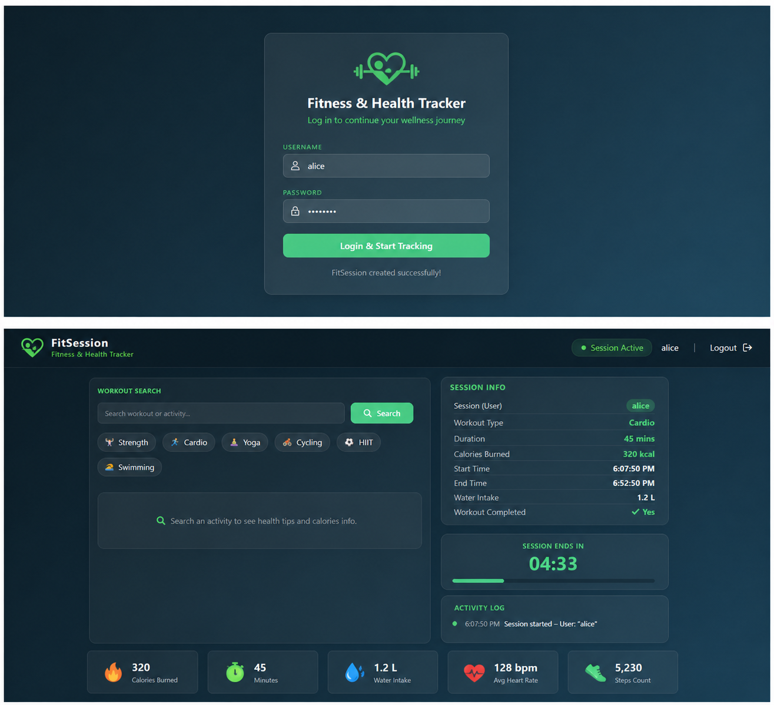
RESULT:
A simple login system is created where the user&#39;s session is tracked by a servlet to
demonstrate session tracking using HttpSession.

